Experiment – 2

Aim - Write a Program for Database Operation in jsp

Program –

Create a database: First create a database named 'student' in mysql and table named "stu_info" in same database by sql query given below:

Create database student
create table stu_info (
ID int not null auto_increment,
Name varchar(20),
City varchar(20),
Phone varchar(15),
primary key(ID)
);

Create a new directory named "user" in the tomcat6.0.16/
webapps and
WEBINF
directory in same directory. Before running this java code you
need to paste a .jar file named mysql connector.jar in the Tomcat6.0.16/
webapps/user/WEBINF/
lib.
prepared_statement_query.jsp
Save this code as a .jsp file named "prepared_statement_query.jsp" in the
directory Tomcat6.0.16/
webapps/user/ and you can run this jsp page with
url http://localhost:8080/user/prepared_statement_query.jsp in address
bar of the browser
<!DOCTYPE HTML PUBLIC "//
W3C//DTD HTML 4.01
Transitional//EN"
53
"http://www.w3.org/TR/html4/loose.dtd" >
<%@ page import="java.sql.*" %>
<%@ page import="java.io.*" %>
<HTML>
<HEAD>
<TITLE>insert data using prepared statement </TITLE>
</HEAD>
<BODY bgcolor="#ffffcc">
<font size="+3" color="green"><br>Welcome in www.roseindia.net
!</font>
<FORM action="prepared_statement_query.jsp" method="get">
<TABLE style="backgroundcolor:
#ECE5B6;" WIDTH="30%" >
<TR>
<TH width="50%"> Name</TH>
<TD width="50%"><INPUT TYPE="text" NAME="name"></TD>
</tr>
<TR>
<TH width="50%">City</TH>
<TD width="50%"><INPUT TYPE="text" NAME="city"></TD>
</tr>
<TR>
<TH width="50%">Phone</TH>
<TD width="50%"><INPUT TYPE="text" NAME="phone"></TD>
</tr>
<TR>
<TH></TH>
<TD width="50%">< INPUT TYPE="submit" VALUE="submit"></TD>
</tr>
</TABLE>
<%
String name = request.getParameter ("name");
String city = request.getParameter ("city");
String phone = request.getParameter ("phone");
String connectionURL = "jdbc: mysql:
Connection connection = null;
PreparedStatement pstatement = null;
Class.forName("com.mysql.jdbc.Driver").newInstance();
int updateQuery = 0;
if(name! =null && city!=null && phone!=null){
if(name!="" && city!="" && phone!="") {
try {
connection = DriverManager.getConnection
(connectionURL, "root", "root");
String queryString = "INSERT INTO stu_info(Name,
Address, Phone) VALUES (?, ?, ?)";
pstatement = connection.prepareStatement(queryString);
pstatement.setString(1, name);
pstatement.setString(2, city);
pstatement.setString(3, phone);
updateQuery = pstatement.executeUpdate();
if(updateQuery != 0) { %>
<br>
<TABLE style="backgroundcolor:
#E3E4FA;"
WIDTH="30%" border="1">
<tr><th>Data is inserted successfully
in database.</th></tr>
</table>
<%
}
}
catch (Exception ex) {
out.println("Unable to connect to database.");
}
finally {
.
pstatement.close();
connection.close();
}
}
}
%>
</FORM>
</body>
</html>

Output –

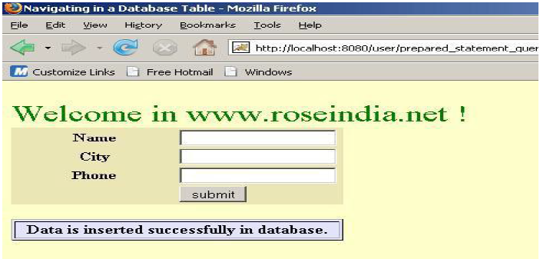

Updating Data :
<%@page language=”java” session=”true”
contentType=”text/html;charset= %>
<font color”blue” Please Enter Your Name </font><br><br>
<form name="frm" method="post" action="updatingDatabase.jsp">
<table border = "0">
<tr align="left" valign="top">
<td>Name:</td>
<td><input type="text" name ="name" /></td>
</tr>
<tr align="left" valign="top">
<td></td>
<td><input type="submit" name="submit" value="submit"/></td>
</tr>
</table>
</form>
Type the url: http://localhost:8080/ServletExample/jsp/update.jsp on your browser. Following output will be displayed:

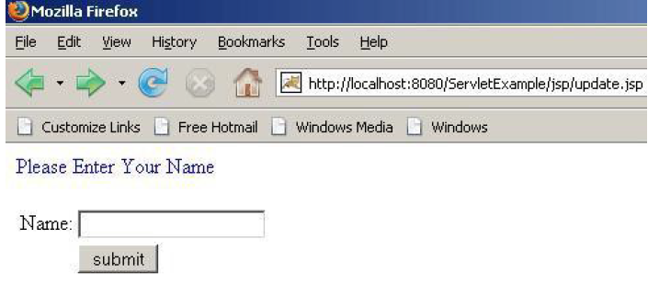

Updating Database.jsp :

<%@ page language = "java" contentType =
"text/html; charset = ISO88591"
import = "java.io.*"
import = "java.sql.*"
import = "java.util.*"
import = "javax.sql.*"
import = "java.sql.ResultSet"
import = "java.sql.Statement"
import = "java.sql.Connection"
import = "java.sql.DriverManager"
import = "java.sql.SQLException"
%>
<%
Connection con = null;
PreparedStatement ps = null;
ResultSet rs = null;
Statement stmt = null;
String name = request.getParameter("name");
Integer id = 5;
%>
<html>
<head>
<title>Updating Database</title>
</head>
<body>
<%
try {
Class.forName("com.mysql.jdbc.Driver");
con =DriverManager.getConnection
("jdbc:mysql://192.168.10.59:3306/example",
"root", "root");
ps = con.prepareStatement("update servlet set
name = ? where id = ?");
ps.setInt(2, id);
ps.setString(1, name);
ps.executeUpdate();
%>
Database successfully Updated!<br>
<%
if(ps.executeUpdate()>=1){
28
stmt=con.createStatement();
rs = stmt.executeQuery("SELECT * FROM servlet");
while(rs.next()){
%>
<%=rs.getObject(1).toString()%>
<%=("\t\t\t")%>
59
<%=rs.getObject(2).toString()%>
<%=("<br>")%>
<%
}
}
} catch (IOException e) {
throw new IOException("Can not display records.", e);
} catch (ClassNotFoundException e) {
throw new SQLException("JDBC Driver not found.", e);
} finally {
try {
if(stmt != null){
stmt.close();
stmt = null;
}
if(ps != null) {ps.close();
ps = null;
}
if(con != null) {
con.close();
con = null;
}
} catch (SQLException e) {}
}
%>
</body>
</html>

After submitting the name, it will be updated in the database and the records
will be displayed on your browser.

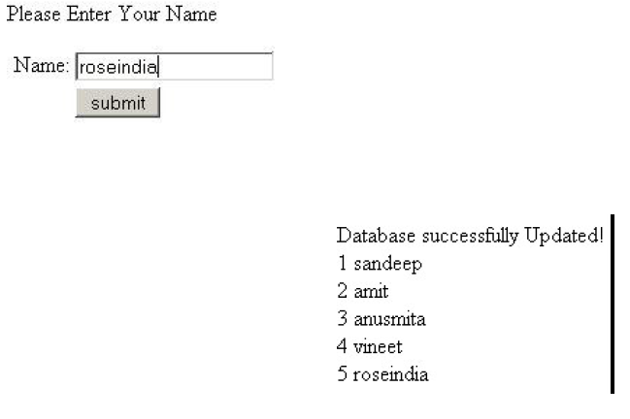

Save this code as a .jsp file named "prepared_statement_query.jsp" in the directory
Tomcat6.0.16/webapps/user/ and you can run this jsp page with url
http://localhost:8080/user/prepared_statement_query.jsp in address bar of the browser.

Result –

Hence we studied how to perform different database operation in jsp.

